MGT 575 - Generative AI and Social Media

PlanWise Final Project Report

Team: CoolAI
Members: Adeline Miao, Xinyi Xu, Erika Liu, Fangyu Li

Table of Contents
Executive Summary 2
Problem Statement and Motivation 2
Data Collection and Preprocessing 2
App Development Overview 5
Technology Stack: 6
- Frontend: React.js, TailwindCSS 6
- Backend: Flask 7
- Database: SQLite 7
- Payments: Stripe Subscription API 8
App Features: 8
- Smart Event Entry 8
- Auto Task Scheduler 10
- Group Availability 11
- Habit Recommendations 12
Conclusion and Future Work 14

Executive Summary
PlanWise is an intelligent schedule management application designed to streamline and optimize the way users plan their lives. Using state-of-the-art technologies in programming like React, Node.js, OpenAI, and Stripe, PlanWise is a highly personalized and easy experience, which goes beyond the traditional calendar application on the market today.

PlanWise offers the ability to create events using natural language input, can interpret tasks and deadlines without user effort, and can offer habit-based suggestions customized to the user's lifestyle. The scheduling capability allows automated task prioritization and group availability awareness, decreasing the level of scheduling complexity for busy people. With offering membership options, users can subscribe on a monthly basis, or choose a one-time membership option (managed by Stripe). Also, the platform comes with an array of smart features unique to PlanWise, such as: mood based plugin for habit suggestions, and natural language processing that is based on OpenAI.

Currently, user data is stored locally, but future developments include database integration, mobile application expansion, and advanced habit analytics. With its clean design, smart functionality, and focus on productivity, PlanWise positions itself as a next-generation personal assistant, helping users manage their time more intuitively and effectively.

Problem Statement and Motivation
As life moves faster than ever, effective time management has become essential. Yet many existing planning tools remain rigid and manually intensive, making them difficult to use consistently — especially for individuals who face challenges with attention and executive functioning. Our motivation to create PlanWise came from a personal experience: one of our team members, who has mild ADHD, shared the daily struggles of managing tasks, schedules, and routines with traditional tools. Through working together, we saw firsthand how existing solutions often fail to support the different ways people actually organize their time.
PlanWise was designed to address this gap. By using Natural Language Processing, the app understands user intent, automatically organizes tasks based on deadlines and priorities, and provides personalized habit recommendations. Our goal is to reduce the cognitive load of planning and offer a more intuitive, seamless experience. PlanWise is built not just to manage calendars, but to enhance productivity and well-being — providing smarter, more flexible support for anyone navigating busy, complex lives.

Data Collection and Preprocessing
A crucial aspect of PlanWise's functionality is its ability to collect, process, and analyze various types of user data to deliver intelligent scheduling and recommendations. This section details our data collection approach and the preprocessing techniques employed. To enable the intelligent features of PlanWise, we developed custom prompts for the OpenAI API that process natural language inputs and transform them into structured data. Below are the specific prompts used for each feature:

Smart Event Entry:
For the Smart Event Entry feature, we implemented a natural language processing system using the following prompt:

For the Smart Event Entry feature, we implemented a natural language processing system using the following prompt:
You are a calendar event assistant. Extract event information from user input and create a simplified title.
Examples:
- Input: "I will have dinner with John tomorrow night at 7pm"
Output: Title should be "Dinner with John", date is tomorrow, time is 7pm
- Input: "Cancel my meeting with marketing team"
Output: Action should be cancel, event to cancel is "meeting with marketing team"
Format your response as a JSON object with these fields:
- action: 'add' or 'cancel'
- title: Simplified event title (remove date/time info, focus on the core event)
- start: Event start time (ISO format)
- end: Event end time (ISO format)
- location: Optional location (if mentioned)
- notes: Optional notes (if any additional information is provided)

Auto Task Scheduler:
The Auto Task Scheduler feature utilizes a sophisticated optimization algorithm guided by the following prompt:

You are a task scheduling assistant. Optimize the user's tasks based on priorities, deadlines, and existing calendar events.
IMPORTANT SCHEDULING RULES:
1. Tasks must NEVER overlap with each other or with existing calendar events
2. Higher priority tasks should be scheduled earlier, especially those with imminent deadlines
3. If a task is longer than ${formattedPreferences.splitTaskThreshold} hours, break it into multiple smaller sessions across different time slots or days
4. Schedule ONLY ONE task per time slot - absolutely no overlapping tasks
5. Strictly honor the user's working hours: Start at ${formattedPreferences.workingHours.startFormatted} and end at ${formattedPreferences.workingHours.endFormatted} each day
6. Include ${formattedPreferences.breakBetweenTasks}-minute breaks between consecutive tasks
7. Schedule a maximum of ${formattedPreferences.maxTasksPerDay} tasks per day, utilizing the full working day
8. Put highest priority on meeting the deadline for each task
9. Schedule tasks efficiently to maximize the use of available time within working hours
Format your response as a JSON array of scheduled tasks, with each task having:
- id: The original task ID
- title: Task title
- start: Start time (ISO format)
- end: End time (ISO format)
- category: Task category (use the original task's category)
- notes: Optional scheduling notes (e.g., "Part 1 of 3" for split tasks)
Each task must have a specific time slot with no overlaps.

Group Availability Coordination
For the Group Availability feature, we created a meeting optimization system with this prompt:
You are a meeting scheduling assistant. Find the best meeting times based on all participants' availability.
Important considerations:
1. Prioritize slots where all participants are available
2. If no slot has 100% availability, find slots with maximum participation
3. Respect preferred days specified in the meeting parameters
4. Ensure the slot duration accommodates the required meeting length
5. Stay within the specified time range
Format your response as a JSON array of available slots, each containing:
- day: Day of the week (e.g., 'monday')
- date: Formatted date (e.g., 'May 1')
- time: Time range (e.g., '10:00 AM - 11:00 AM')
- availability: 'all' or 'partial'
- availableCount: Number of available participants (if partial)
- totalCount: Total number of participants
Sort the slots by best fit (all available first, then by number of available participants).

Habit-Based Recommendations
The Habit Recommendations feature uses the following prompt to analyze user activity and mood data:
You are a personalized habit recommendation assistant. Analyze the user's mood patterns and activities to suggest an ideal daily schedule.
Consider:
1. Time-specific mood patterns (morning, afternoon, evening)
2. Activities that correlate with positive moods
3. Balance across different activity categories
4. Sustainable habit formation principles
Format your response as a JSON array of recommendation blocks, each with:
- id: Unique identifier for the recommendation
- title: Section title (e.g., 'Morning Routine', 'Productivity Boost')
- activities: Array of suggested activities with:
- time: Suggested time (e.g., '07:00 AM')
- description: Activity description
- category: Category ID (e.g., 'selfCare', 'work', 'exercise')
The recommendations should be detailed yet realistic for daily implementation.

PlanWise collects several types of user data to power its features:
- User-Entered Events: Calendar events entered through the natural language interface or manual input forms are stored in a structured format with title, date, time, and optional location and notes fields.
- Task Information: Users input tasks with estimated duration, priority level, deadline, and category (e.g., work, personal, study).
- Group Availability Data: For meeting coordination, the system collects availability preferences from all participants, storing time slots when each user is available.
- Mood and Activity Logs: Users can record their daily mood (e.g., happy, sad, energetic, tired) and log completed activities categorized by type (e.g., exercise, work, leisure, self-care).

Before processing the collected data with our AI components, PlanWise applies several preprocessing techniques: All temporal data is converted to a consistent ISO 8601 format to ensure proper comparison and processing. User inputs are validated for completeness and correctness, with appropriate error messages and suggestions for correction. Natural language inputs are enriched with context information, such as the user's time zone and existing calendar events, to improve interpretation accuracy. For habit recommendations, the system aggregates mood and activity data across similar contexts (e.g., weekdays vs. weekends, mornings vs. evenings) to identify meaningful patterns. This comprehensive data collection and preprocessing approach, combined with our AI prompts, enables PlanWise to deliver intelligent scheduling solutions that adapt to each user's unique needs and preferences.

App Development Overview
PlanWise was conceived as a comprehensive solution to address the challenges of modern time management and productivity. The development process followed an iterative approach, starting with core functionality and progressively incorporating advanced features. This section outlines the technology choices, development methodology, and key implementation considerations that shaped the final application.

We employed an agile development methodology with weekly sprints, allowing for continuous feedback and iteration. The project was divided into four main phases:

- Requirements Analysis and Design: Identifying user needs, creating wireframes, and establishing the core feature set.
- Core Infrastructure Development: Setting up the technology stack, authentication systems, and basic application structure.
- Feature Implementation: Developing the four main features (Smart Event Entry, Auto Task Scheduler, Group Availability, and Habit Recommendations) in priority order.
- Integration and Refinement: Connecting all components, implementing the payment system, and optimizing performance.

This approach allowed us to maintain a focused development process while adapting to challenges and insights that emerged during implementation.

A significant aspect of our development strategy involved leveraging generative AI to accelerate the implementation process. The main technical architecture and implementation were developed using Claude, an advanced AI assistant. We provided Claude with a comprehensive prompt detailing the application requirements, desired features, and technical specifications.

The original prompt used to generate the application is reproduced below:

make me an app!
I want to build a react application called "PlanWise" with the following features:
1. core functionality:
- home page user can login with username and password and login button, or click create account button.
- if login, just take them to the main app page "Smart Event Entry"
- if create account, users create an account with first name, last name, username, password (no dbs setup yet, so for now just save this somewhere locally like login_info.csv with cols username, password) and click "create account"
- Then next page is membership type. users choose basic plan $0, only can use main app page "Smart Event Entry", monthly plan $5, for Premium Features, or $80 for whole life membership.
- next page is payment page. Here they enter credit card info and click pay. Stripe will handle paymet. Each of these options has a sepearte stripe price id. All the relevant API keys are in my 2 .env files, one for the front end and one for the backend server that handles the stripe payment. Just tell me what to call the variables in these 2 .env files.
- next if payment is successful, it goes to the page Smart Event Entry. and all other feature panel will not show grey locked sign.
- on Smart Event Entry page, there's calendar, and also chatbox. the user can use Natural language input like "Lunch with Sarah next Friday at noon" gets parsed into calendar entries. use API.
- Add a logout button to the top that takes me back to the login page.
- premium feature (locked if not a membership): Auto Task Scheduler: Input tasks and deadlines, auto-generate optimal schedules. Users input all tasks they want to complete and their respective deadlines. The system automatically generates an efficient schedule based on time slots and task priorities; using color coding to mark different types of tasks (study, entertainment, fitness, etc.)
- premium feature (Locked if not a membership): Group Availability Coordination: Multiple users can input their availability and find common free time slots. Try the same thing as https://www.when2meet.com/
- Habit-Based Recommendations: Daily routine suggestions based on the user's past behavior. The system recommends an "ideal schedule" each day based on your past behavior habits and emotional state (which you rate). Used for time management & emotional management (Morning Journal, Evening Reflection). Users can record their daily mood. (you can have signs like "happy" "sad", etc.)

2. Visual Design:
- use as concise as possible scheme. make all things easy to understand, easy to use.
- name it "PlanWise"
3. Technical Requirements:
- Built with React (create-react-app)
- Use Stripe for handling payment on a seperate backend java server
- Use Tailwind CSS for styling
- Make it responsive for different screen sizes
Please generate ALL the necessary files for this application:
1a. A complete package.json with all required dependencies for front end
1b. A complete package.json with all required dependencies for backe end
2. App.js with the full React component
3. tailwind.config.js for the Tailwind setup
4. postcss.config.js for PostCSS configuration
5. index.css with all required styles including Tailwind directives
6. server.js file with backend server code
7. A components folder with all the component files. Put all compents in here, so App.js can import them. This makes the app more modular and eaiser to edit.

I will create an app in VS code, and then add in or edit the app files. Please provide a full file directory and insttructions on what to created or edit, and how to run the app. Assume I begin with VS code and have already installed nodjs.

Based on this detailed prompt, Claude generated a complete codebase including frontend components, backend server code, configuration files, and comprehensive integration instructions. The AI-generated solution implemented all requested features while adhering to modern web development best practices.

This AI-assisted approach provided several advantages:

- Rapid prototyping and implementation of complex features;
- Consistent code structure and styling across components;
- Built-in best practices for React and modern web development;
- Seamless integration between various technologies.

The architecture and implementation were inspired by the "Wickedly Viral" application discussed in our course lectures, which demonstrated effective integration of React with payment processing systems and data visualization capabilities. We adapted these concepts to the specific requirements of PlanWise while incorporating additional features tailored to our target users.

Technology Stack:

- Frontend: React.js, TailwindCSS
After evaluating several technology options, we selected a modern stack that balances performance, developer productivity, and user experience. For our frontend implementation, we chose React.js as the foundation, which offers several critical advantages. React's component-based approach enabled us to create modular, reusable UI elements that significantly accelerated development, particularly valuable for complex interfaces like the calendar display and task scheduler. React's virtual DOM implementation ensures optimal performance even when handling complex state changes, such as real-time updates to schedules or collaborative availability tracking. The extensive React ecosystem provided pre-built solutions for common challenges, including calendar visualization with react-big-calendar, routing via react-router-dom, and form handling through formik. Additionally, hot reloading, comprehensive developer tools, and a declarative programming model reduced development time and simplified debugging.

To complement React, we implemented TailwindCSS as our styling framework. This utility-first CSS framework streamlined styling and ensured a consistent, responsive design across the application. Tailwind's utility classes eliminated the need for custom CSS in most cases, accelerating UI development and maintaining consistency throughout the interface. The built-in responsive utilities made it straightforward to create layouts that work seamlessly across devices, from mobile phones to desktop displays. We extended Tailwind's default configuration to incorporate our application's color scheme and typography, creating a cohesive visual identity. For production deployment, we used PurgeCSS to remove unused styles, resulting in a minimal CSS footprint and improved load times.

- Backend: Flask
On the backend, we selected Flask as our framework for its lightweight nature and flexibility. Unlike more opinionated frameworks, Flask's microframework architecture provided the freedom to choose components and libraries that specifically addressed our requirements without unnecessary overhead. Flask's Python foundation allowed us to leverage powerful libraries for natural language processing (NLTK, spaCy) and machine learning (scikit-learn) when implementing the Smart Event Entry and Habit Recommendations features. The framework's route decorators and minimal boilerplate code facilitated rapid development of our RESTful API endpoints. Through extensions like Flask-RESTful, Flask-JWT-Extended, and Flask-CORS, we added specific functionality while maintaining a clean codebase. Flask applications can be deployed in various environments, from simple web servers to containerized solutions, providing options for future scaling as user adoption grows.

- Database: SQLite
For data persistence, we chose SQLite based on several important considerations. SQLite's file-based database structure eliminated the need for a separate database server, simplifying development and deployment of the application. The database's ACID compliance ensured data integrity even during complex operations involving multiple users or concurrent modifications. Through SQLAlchemy, we implemented an object-relational mapping layer that provided a clean abstraction over the database, making it easier to work with data models in an object-oriented fashion. For our expected user load, SQLite offers sufficient performance while minimizing infrastructure requirements. The SQLAlchemy ORM also provides an abstraction layer that would allow us to migrate to a more robust database system (e.g., PostgreSQL) as user numbers grow, without requiring significant code changes.

- Payments: Stripe Subscription API
To handle our tiered membership model, we integrated the Stripe Subscription API into the application. Stripe's subscription API provides robust handling of recurring billing, including free trials, plan changes, and cancellations, which are essential for our membership tiers. By delegating payment processing to Stripe, we inherit their PCI DSS compliance, substantially reducing security risks and implementation complexity. Stripe webhooks allow our application to respond to payment events (successful payments, failed payments, subscription cancellations) without constant polling for updates. Stripe's well-documented APIs and client libraries for both JavaScript and Python significantly simplified integration with our frontend and backend systems. The Stripe dashboard provides valuable insights into subscription metrics, helping us understand user conversion and retention patterns over time.

App Features:

- Smart Event Entry
The "Smart Event Entry" module is one of the core functionalities of PlanWise, designed to streamline the process of scheduling personal events through intelligent natural language input. Instead of manually selecting dates and times from a calendar, users can simply type commands such as "Dinner with Miao tomorrow at 7pm" into the text box located at the bottom of the interface. PlanWise automatically interprets the input, identifies the relevant date and time, and generates a new event entry on the user's calendar.
Upon successful parsing, the newly added event immediately appears within the dynamic calendar view, which supports multiple formats including monthly, weekly, and daily perspectives. Users can easily navigate between different time frames using the "Today," "Back," and "Next" buttons, enhancing usability and flexibility. Additionally, users have the option to clear all events with a single click, allowing for quick schedule resets when necessary.
The Smart Event Entry system leverages natural language processing (NLP) techniques to enable more intuitive interaction with the calendar, moving beyond the traditional, form-based event creation methods typically found in standard scheduling apps. This approach lowers the barrier for users to maintain and update their schedules, making it easier and faster to record activities without disrupting their workflow.
In terms of technical implementation, the Smart Event Entry feature integrates a lightweight frontend parsing logic that recognizes common scheduling phrases (e.g., "tomorrow," "at 7pm") and translates them into specific timestamps. These are then recorded into the internal event data structure and visually reflected on the calendar. The system also provides real-time user feedback by confirming actions, such as displaying a message like "Added 'Dinner with Miao' to your calendar on Tuesday, April 29, 2025, 7:00 PM to 8:00 PM."
Overall, Smart Event Entry exemplifies PlanWise's mission of creating a smarter, more user-centered scheduling experience. By allowing users to naturally "talk" to their calendar, PlanWise significantly enhances engagement, reduces scheduling friction, and introduces an intelligent yet accessible approach to personal time management.
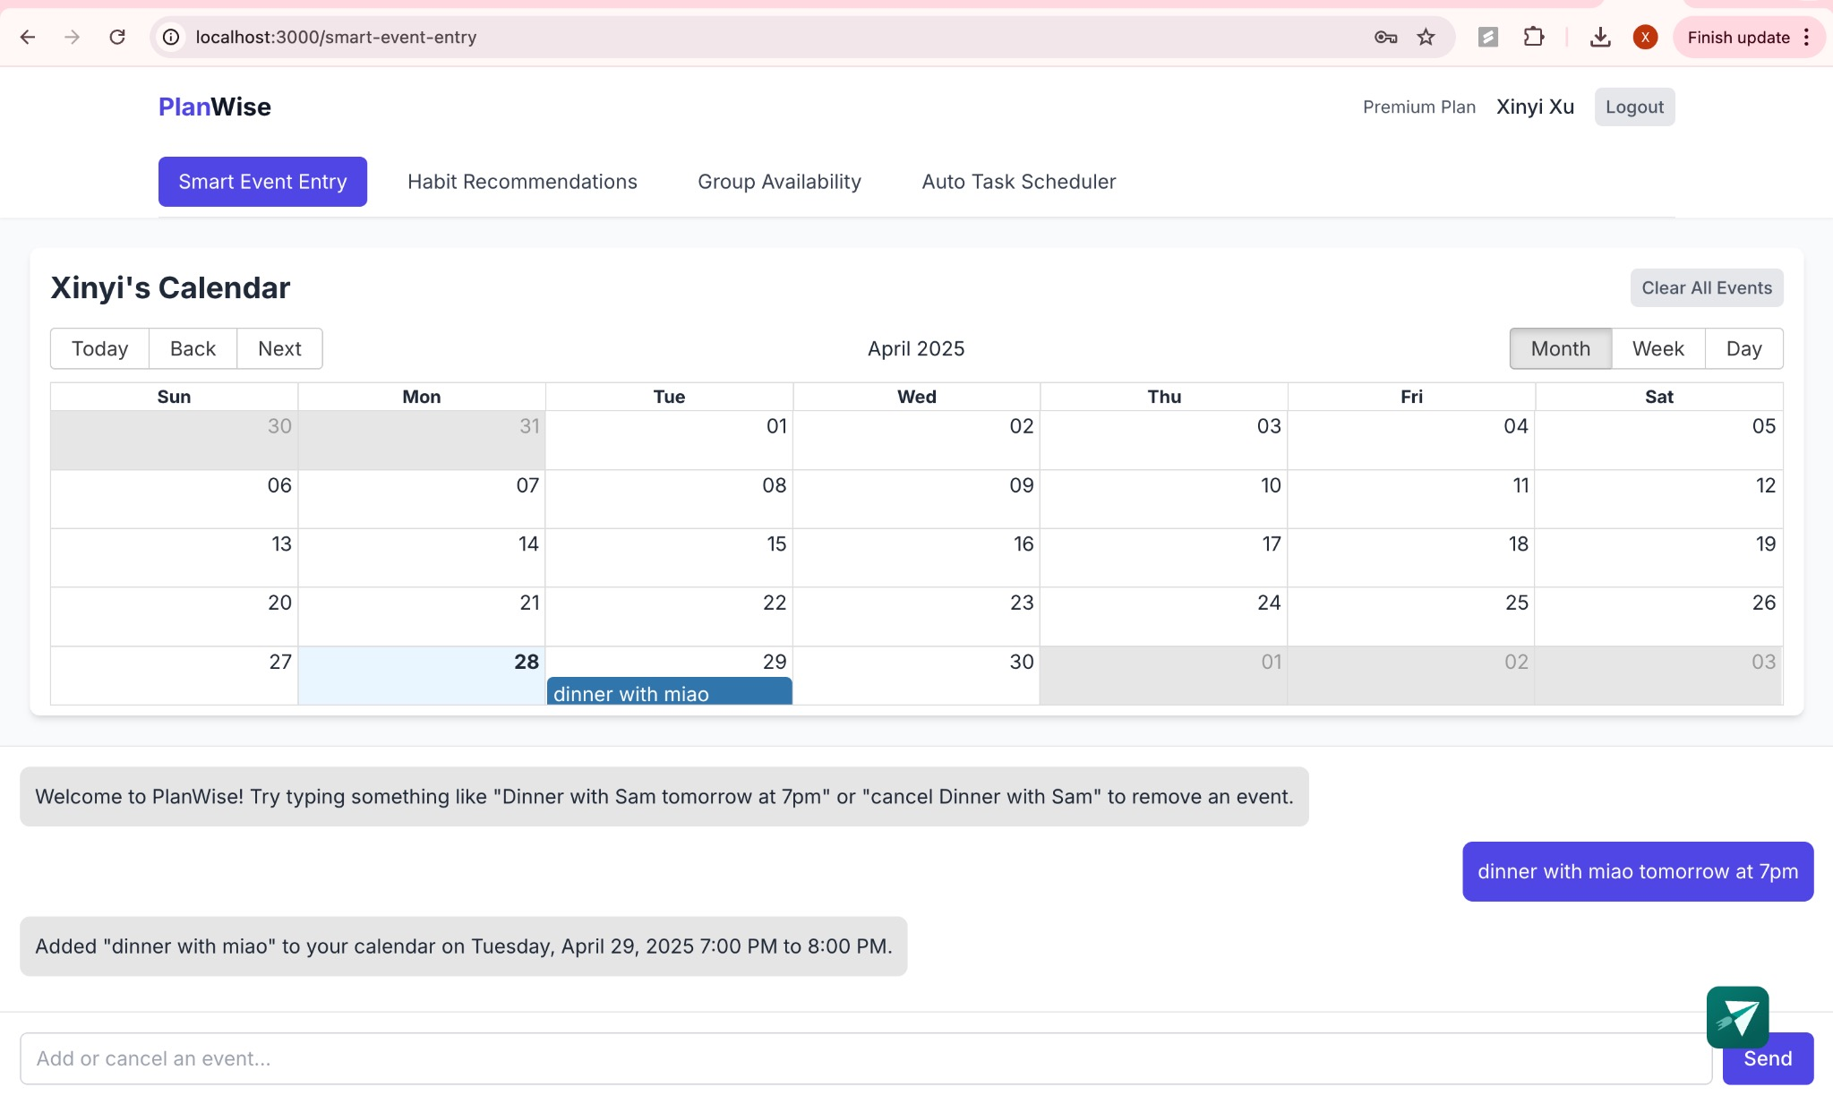
Figure 1: Smart Event Entry interface
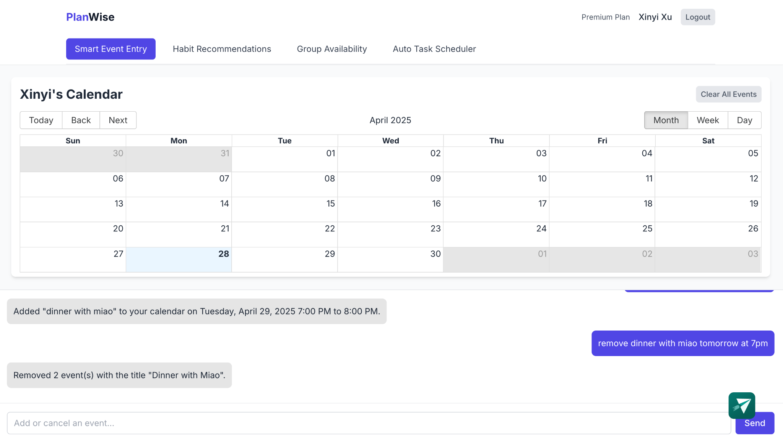

Figure 2. Smart Event Entry: Removing an Existing Calendar Event via Natural Language Command

- Auto Task Scheduler
The "Auto Task Scheduler" module in PlanWise helps users efficiently organize their tasks by automatically generating an optimized daily and weekly schedule. Instead of manually planning each task, users simply input task details and allow the system to intelligently place them into available time slots based on their deadlines, estimated duration, and priority levels.
Users begin by entering task information such as the task name, deadline date and time, estimated hours required, category (e.g., Work, Study, Exercise), and priority (High, Medium, Low). They can add multiple tasks to a centralized Task List. Additionally, users can configure scheduling settings, including working hours, the maximum number of tasks per day, break times between tasks, and whether longer tasks should be split into smaller segments.
After tasks are added and preferences are set, users click the "Schedule Tasks" button. PlanWise then automatically generates an optimized schedule, displaying tasks in a calendar view across Today, Tomorrow, and upcoming days. Tasks are visually blocked into the calendar based on priority and deadlines, helping users stay focused and organized without needing to manually allocate time.
The system also offers flexibility: users can clear their schedule to make adjustments if needed, and tasks can be rescheduled as priorities evolve. The goal of the Auto Task Scheduler is to reduce the burden of planning while ensuring that important tasks are completed on time with a balanced workload across the day and week.
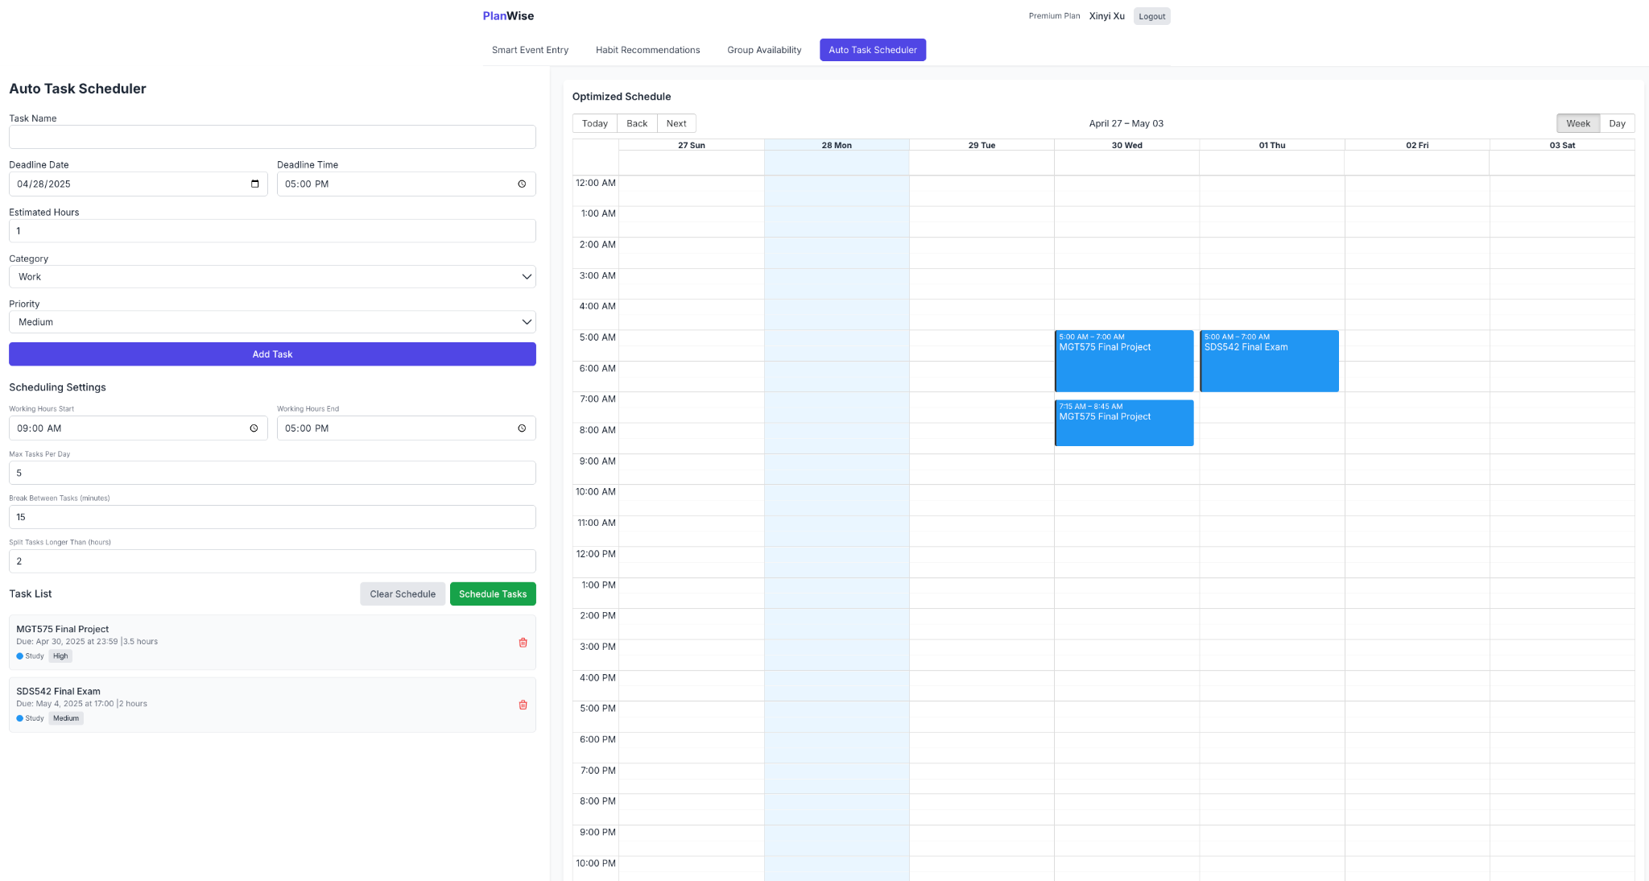
Overall, the Auto Task Scheduler enhances productivity by offering users a smart, time-saving solution for managing their responsibilities. It supports better time management, reduces decision fatigue, and helps users maintain a structured yet adaptable daily routine.

Figure 3. Auto Task Scheduler: Task Input and Scheduling Configuration Interface

- Group Availability
The "Group Availability" module in PlanWise streamlines the process of organizing meetings and collaborative sessions by efficiently identifying optimal time slots that accommodate all invited participants. It eliminates the traditional challenges of manual coordination and back-and-forth messaging, providing a centralized solution for seamless group scheduling.
To initiate the scheduling process, users create a new group meeting by entering the meeting name and specifying the estimated meeting duration. They then add participants by inputting email addresses, with the flexibility to add multiple members at once. In addition, users can customize their meeting preferences by selecting preferred meeting days (e.g., Monday through Friday) and a desired time range for availability (e.g., 9:00 AM to 6:30 PM). These settings ensure that the proposed meeting options align with the participants’ typical working hours and availability patterns.
After setting up the basic information, users click the "Find Available Times" button. PlanWise then analyzes the availability of all participants and generates a list of the best matching time slots. Available slots are clearly displayed, with indicators such as "All available" or "2/3 available" to show participant attendance at a glance. This visibility helps users quickly assess which time slots are ideal for maximum participation.
Once a suitable time is identified, users can simply click "Schedule Selected Slot" to finalize the meeting. The scheduled meeting details are saved within the system, reducing administrative overhead and ensuring that all participants are aware of the agreed-upon time.
The Group Availability feature also supports flexibility: if users wish to adjust meeting parameters or add/remove participants, they can easily modify the setup and refresh the available options. This adaptability ensures that last-minute changes can be accommodated without restarting the entire scheduling process.
By offering an intuitive, user-friendly interface and a streamlined scheduling experience, Group Availability significantly reduces the time and cognitive effort required to organize group meetings. It fosters better collaboration by removing friction from the planning process, allowing teams to focus more on the content and goals of their meetings rather than the logistics of finding a common time.
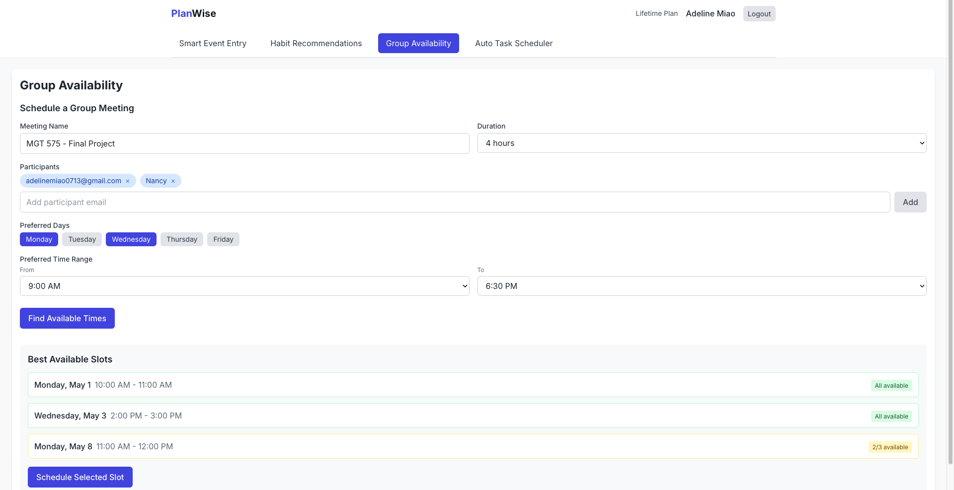

Figure 4. Group Availability: Scheduling a Group Meeting Based on Participants’ Preferred Times

- Habit Recommendations
The "Habit Recommendations" module in PlanWise is designed to help users build healthier daily routines by combining mood tracking, activity logging, and self-reflection into an integrated scheduling experience. This feature provides users with a structured yet flexible way to monitor their emotional states, daily habits, and personal growth, ultimately supporting more personalized and effective time management.
Users can easily record their mood at different times of the day—Morning, Afternoon, and Evening—through a simple emoji-based selection system. Mood options such as "Great," "Good," "Okay," "Down," and "Bad" make it quick and intuitive to log emotional states without interrupting daily activities. Alongside mood tracking, users can log their actions and categorize them under key domains such as Work, Study, Exercise, Leisure, Social, Self-Care, and Sleep. This dual-logging system enables a holistic view of the user's day and highlights connections between behavior and well-being.
Based on the patterns detected from moods and activities, PlanWise dynamically generates personalized daily recommendations. These suggestions are organized into Morning Routine, Afternoon Productivity Boost, and Evening Wind-Down categories. Recommendations are tailored to reinforce positive habits, such as incorporating morning exercise, planning balanced meals, or setting aside time for mindfulness. Users can also refresh their recommendations at any time to reflect newly logged entries and ensure their schedule adapts to evolving needs.
In addition to tracking and recommending activities, Habit Recommendations includes an Evening Reflection feature. Each evening, users are prompted to reflect on their day through a guided journal entry, with questions such as "What went well today?", "What could have gone better?", and "What am I grateful for today?" Users can freely write their reflections into a text box and save them for future review. This encourages daily self-awareness, gratitude practice, and goal setting for the following day, helping users end each day with intention and mindfulness.
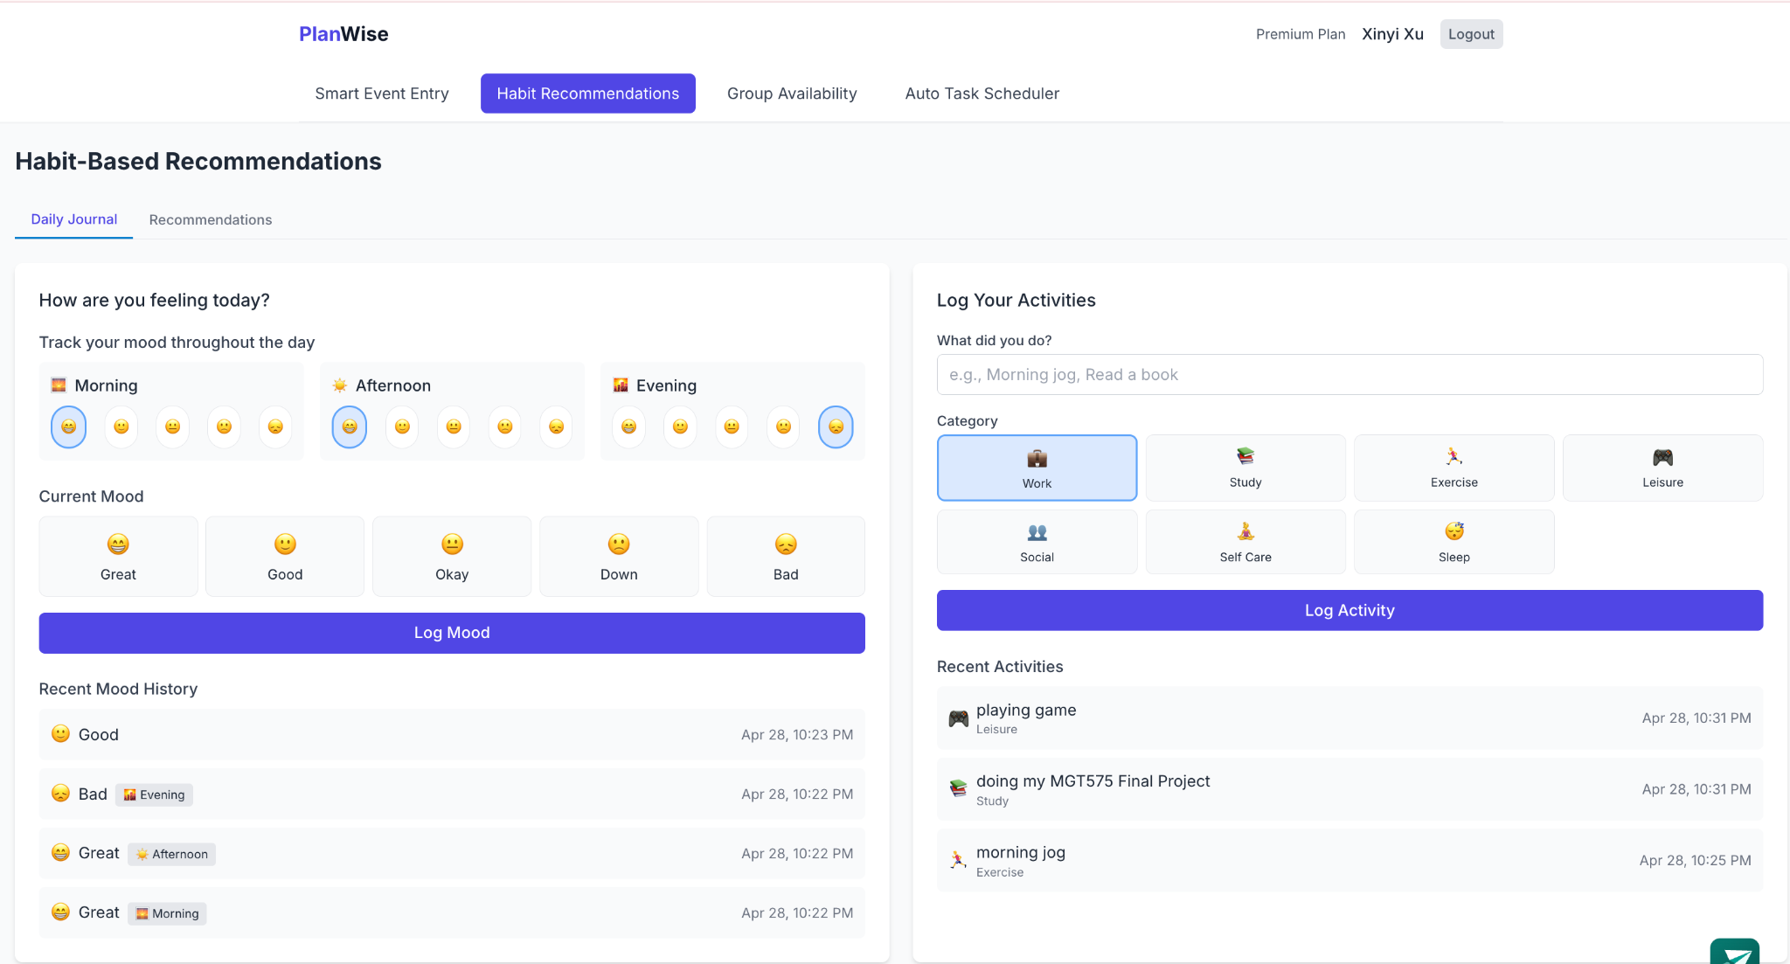
Overall, Habit Recommendations enhance the user's scheduling experience by offering tailored, actionable insights while promoting emotional well-being, habit formation, and continuous personal development.

Figure 5. Mood and Activity Logging Interface
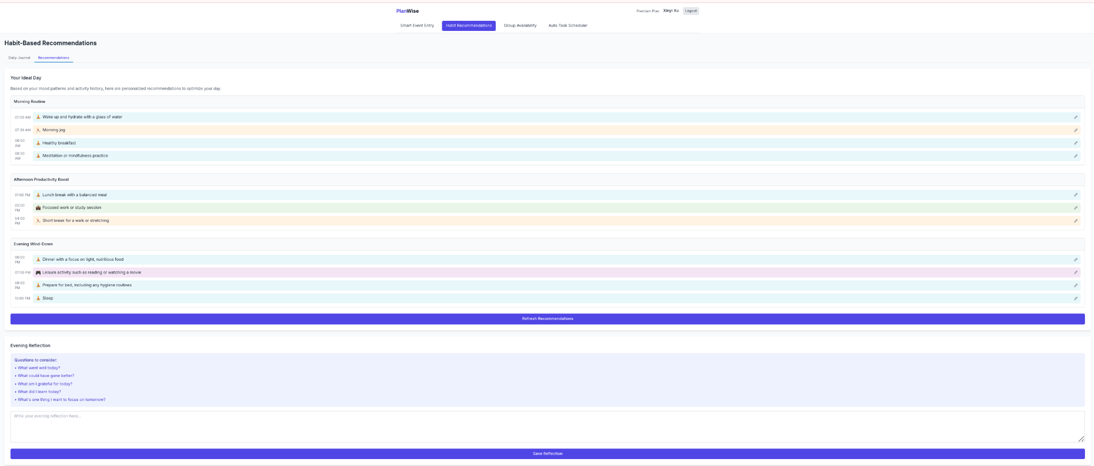
Figure 6. Personalized Daily Routine Suggestions

Conclusion and Future Work
PlanWise intends to make a smart, holistic approach to modern time management and group coordination options possible. PlanWise is offered as a simple unified solution that combines: a Smart Event Input, Auto Task Scheduling capabilities, Habit Based Recommendations capabilities and Group Availability into one solution that makes scheduling easier both personally and group-wise. By utilizing natural language based input, task-focused dynamic input and habit continuity based recommendations, PlanWise users gain not only better organization, but awareness and intentionality around their daily habits.
Planwise has collectively achieved its intended goals, and there are still some exciting development possibilities on the horizon. Some key development opportunities include increased natural language understanding capabilities to accommodate endless variable input for events, integration of various online services such as Google Calendar and online Outlook, long-term behavioral tracking of users to provide better habit recommendations, real-time notifications for pending tasks for users, improved group coordination features, and an expansion of the PlanWise user base via a mobile application.
Moving forward, PlanWise's ultimate purpose is to become a fully adaptive productivity assistant, providing the user with far more than a simple tool to manage their scheduling and tasks, but also helping users create positive habits, collaborate with others, and create sustainable growth for themselves both personally and professionally.

